The Solar System: Laws of Planetary Motion and Universal Gravitation
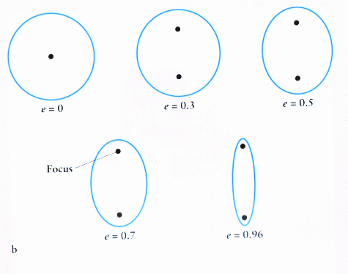
Name:____________________________ Block:_____________
Kepler’s 3 Laws of Planetary Motion:
First Law: Law of Elliptical Orbits
All celestial objects have ______________ orbits, in which they have ______ focal points. The ____________ is always one of the foci.
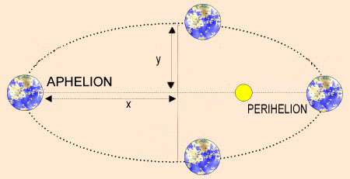
- Eccentricity is numerically how stretched out the planet’s orbit is. The further the focal points are in an ellipse, what happens to the eccentricity?___________
- What happens to the shape? ______________
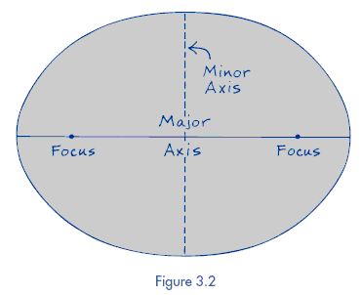
Aphelion: ________________
Perihelion: _______________
How do we calculate eccentricity? Found on page 1 of the ESRT
Eccentricity = ____________________________________

The major axis should always run through the ___________ ______________
Range for Eccentricity: ________ to _______
0: _______________ 1: _____________ -neither exist!
Which planet has the lowest eccentricity and of what value? ____________ ____________
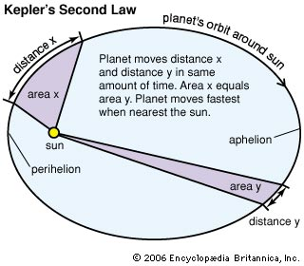
Which planet has the greatest eccentricity and of what value? ___________ ______________
2nd Law of Motion: Varying Velocities
- Speed will ____________ as distance to the sun decreases (because gravity increases)
- When is earth moving the fastest? ______________________ Slowest? ________________
- Equal areas of an ellipse will be covered in equal amounts of time. When a planet moves slower, it covers less distance along the orbital path, but an equal area of the orbit itself.
3rd Law of Motion: Harmonic Law
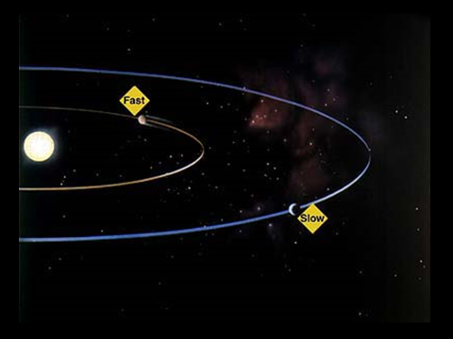
The further a planet is from the sun, the _____________ its period of revolution

Newton’s Law of Universal Gravitation
The gravitational strength between two bodies is due to the following two variables:

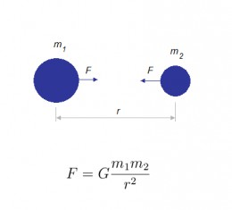
For mass (m), it states:

Simplified:

G=

For distance(r), it states:

Simplified:

Equation relationships: So if the mass of earth were to double….
Mass: G=

Distance: G= If the distance between the earth and sun were to double…

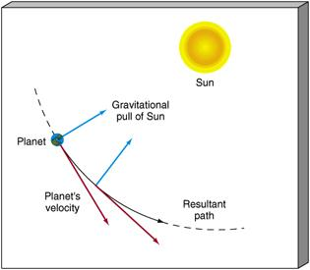
A planets orbit is the balance between ___________________ (velocity in a straight line motion) and ___________ (inwards).

If the sun were to suddenly disappear, towards which direction would earth move in the diagram?

